Packet Tracer - Skills Integration Challenge

1. Topology

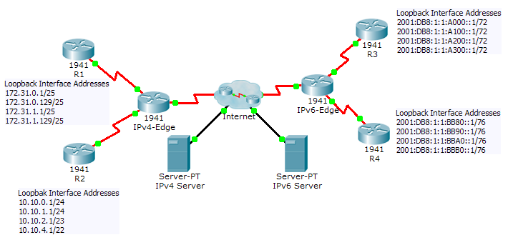

Addressing Table

|  |  |  |  |
| --- | --- | --- | --- |
| Device | Interface | IPv4 Address | Subnet Mask |
| IPv6 Address/Prefix | |
| IPv4-Edge | S0/0/0 | 172.31.6.1 | 255.255.255.252 |
| S0/0/1 | 10.10.8.1 | 255.255.255.252 |
| S0/1/0 | 209.165.200.226 | 255.255.255.224 |
| R1 | S0/0/0 | 172.31.6.2 | 255.255.255.252 |
| R2 | S0/0/1 | 10.10.8.2 | 255.255.255.252 |
| IPv6-Edge | S0/0/0 | 2001:DB8:A001:6::1/64 | |
| S0/0/1 | 2001:DB8:A001:7::1/64 | |
| S0/1/0 | 2001:DB8:CAFE:1::2/64 | |
| R3 | S0/0/0 | 2001:DB8:A001:7::2/64 | |
| R4 | S0/0/1 | 2001:DB8:A001:6::2/64 | |

1. Scenario

In this activity, you are tasked with implementing EIGRP for IPv4 and IPv6 on two separate networks. Your task includes enabling EIGRP, assigning router-IDs, changing the hello timers, configuring EIGRP summary routes and limiting EIGRP advertisements.

1. Requirements

EIGRP for IPv4

* Implement EIGRP on IPv4 enabled routers using Autonomous System 1.
  1. Use the classful network address for the loopback interfaces.
  2. Use the wildcard mask to advertise the /30 networks between **R1**, **R2** and **IPv4-Edge**.
  3. Use the **default** method to only allow EIGRP updates out the active EIGRP serial interfaces.
  4. Advertisements should not be summarized.
* Configure a directly attached default route on **IPv4-Edge** and propagate it in EIGRP updates.
* Configure the serial interfaces between **R1**, **R2** and **IPv4-Edge** to send hellos every 10 seconds.
* On **R1** and **R2**, configure an EIGRP summary route for the loopback networks.

|  |  |
| --- | --- |
| R1 Loopback Networks | R2 Loopback Networks |
| 172.31.0.0/25 | 10.10.0.0/24 |
| 172.31.0.128/25 | 10.10.1.0/24 |
| 172.31.1.0/25 | 10.10.2.0/23 |
| 172.31.1.128/25 | 10.10.4.0/22 |
| Summary: | Summary: |

* **R1** and **R2** should only have four EIGRP routes in the routing table, one of which is the default route (D*EX). **IPv4-Edge** should only have two EIGRP routes in the routing table.
* Verify **R1** and **R2** can ping the **IPv4 Server**. **IPv4 Server** should also be able to ping every loopback address on **R1** and **R2**.

EIGRP for IPv6

* Implement EIGRP on IPv6 enabled routers using Autonomous System 1.
  1. Assign **IPv6-Edge** with the router-ID of 1.1.1.1
  2. Assign **R3** with the router-ID of 3.3.3.3
  3. Assign **R4** with the router-ID of 4.4.4.4
* Configure a directly attached default route on **IPv6-Edge** and propagate it in EIGRP updates.
* On **R3** and **R4**, configure an EIGRP summary route for the loopback networks.

|  |  |
| --- | --- |
| R3 Loopback Networks | R4 Loopback Networks |
| 2001:DB8:1:1:A000::1/72 | 2001:DB8:1:1:BB80::1/76 |
| 2001:DB8:1:1:A100::1/72 | 2001:DB8:1:1:BB90::1/76 |
| 2001:DB8:1:1:A200::1/72 | 2001:DB8:1:1:BBA0::1/76 |
| 2001:DB8:1:1:A300::1/72 | 2001:DB8:1:1:BBB0::1/76 |
| Summary: | Summary: |

* **R3** and **R4** should only have four EIGRP routes in the routing table, counting the default external route. **IPv6-Edge** should only have two EIGRP routes in the routing table.
* Verify **R3** and **R4** can ping the **IPv6 Server**. **IPv6 Server** should also be able to ping every loopback address on **R3** and **R4**.

1. Suggested Scoring Rubric

**Note:** Packet Tracer does not currently grade EIGRP for IPv6 summary routes. Therefore, part of your grade depends on routing table verification by your instructor.

|  |  |  |
| --- | --- | --- |
| Scored Work | Possible Points | Earned Points |
| **IPv6-Edge Routing Table** | **10** |  |
| **Packet Tracer Score** | **90** |  |
| **Total Score** | **100** |  |